SMAPVEX12 Forest soil moisture ground truth measurement header file

Column A: Date of measurement (dd-mm-yy)

Column B: Forest site ID (F1, F2, F3, F5)
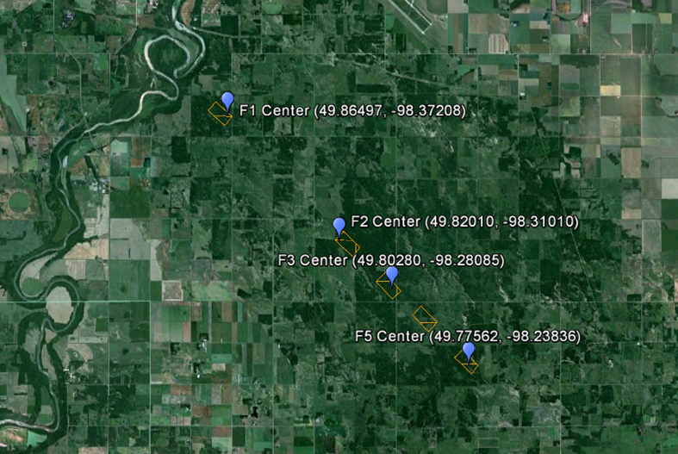

Column C: Sample location (Location ID) within forest sites

Column D&E: GPS coordinates of sample location (lat, long)

Colum F – I: Organic soil thickness (in inches) at four corners of a 10 inch quadrat
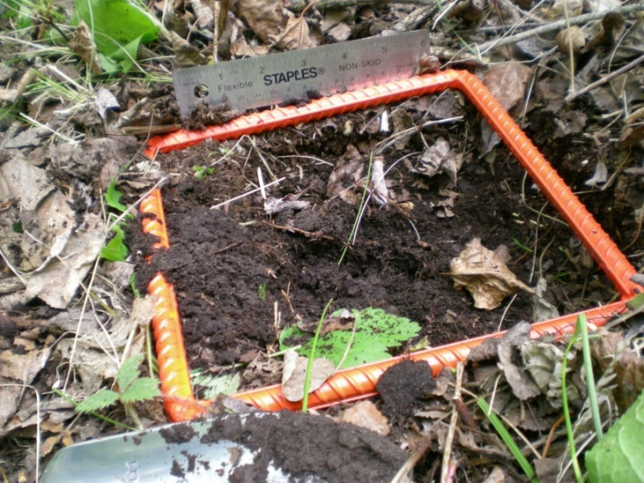

Column J – L: Three soil moisture measurements at 5 cm depth

Column M: Probe type used in soil moisture measurement (hydra or theta probe)

Column N: Surface temperature measurement (T0) in degrees Celsius

Column O: Temperature measurement at 5 cm (T5) in degrees Celsius

Column P: Temperature measurement at 10 cm (T10) in degrees Celsius

Column Q – V:
- Column Q&R: Real and imaginary part of dielectric constant for first soil moisture sample (Column J)
- Column S&T: Real and imaginary part of dielectric constant for second soil moisture sample (Column K)
- Column U&V: Real and imaginary part of dielectric constant for third soil moisture sample (Column L)

